CSS Typewriter Effect 1

Step 1:

Create 2 files index.html and style.css

Step 2:

In Index.html, write following code:

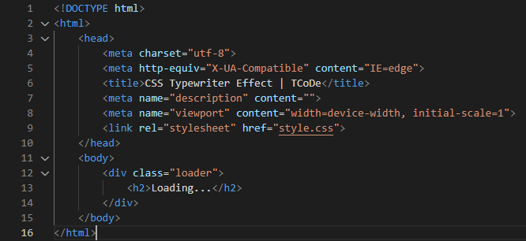

In the code given above,

* + It is a basic skeleton of webpage which includes <html> tag, <head> tag, <body> tag.
  + Inside <head> tag, we include <Title> tag, which displays name of our website in browser’s tab.
  + We also include <Link> tag which is link to our **external CSS file**.
  + href=” style.css” links CSS page with our html page.
  + Inside <Body> tag, we include all data we want to display on a web-page.
  + <Div> tag is used to create a division inside a webpage. It has attribute class which we are going to use in CSS to style the content of the webpage.
  + <H2> tag is used for heading. It has different sizing from H1-H6 in html.

Step 3:

In style.css, write the following code

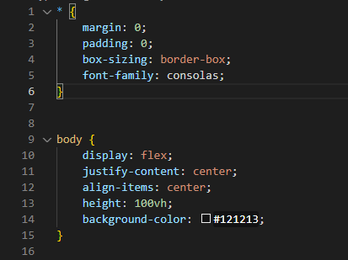

In the above give code,

* “*” is used for all the content in a web page.
* The box-sizing property defines how the width and height of an element are calculated.
* The font-family property defines which font to be include in over-all webpage.
* Body defines designing on the web-page body.
* Display: flex - The Flexible Box Layout Module, makes it easier to design flexible responsive layout structure without using float or positioning.
* Justify-content: center – It makes the content in center horizontally.
* Align-items: center – It makes the content in center vertically depending upon the height specified.
* Height: 100vh – It defines height of a content in “*vh”* (viewport height – 1 vh = height of viewport, i.e., if viewport is 800px then, 1vh is 8px).
* Background-color – Defines the color of the background.

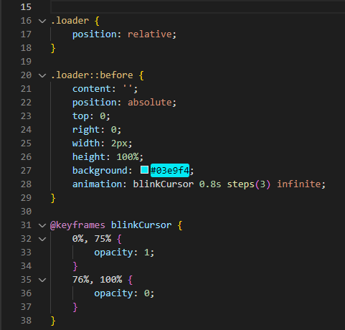

In the above code,

* .loader – is a class name we define in <div> tag in our html code.
* An element with position: relative; is positioned relative to its normal position. Setting the top, right, bottom, and left properties of a relatively-positioned element will cause it to be adjusted away from its normal position.



* .loader::before - The ::before selector inserts something before the content of each selected element(s).
* position: absolute - An element with position: absolute is positioned relative to the nearest positioned ancestor (instead of positioned relative to the viewport, like fixed).
* Animation : blinkCursor 0.8s step() infinite – ***blinkCursor*** is animation name, ***0.8s*** is duration, ***steps(3)*** animation-timing-function and ***infinite*** is iteration.
* @keyframes blinkCursor - When you specify CSS styles inside the @keyframes rule, the animation will gradually change from the current style to the new style at certain times.
* 0%, 75% {opacity : 1;} – The opacity of the content will be 1 from 0% to 75%.
* 76%, 100% {opacity : 0;} – The opacity of the content will be 0 from 76% to 100%.

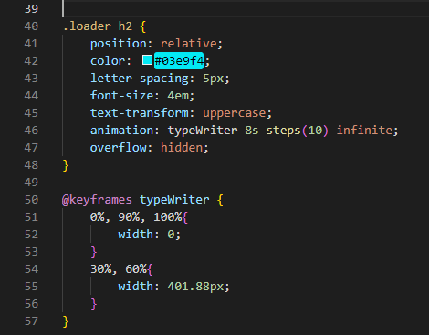

In the above code,

* .loader h2 – selects h2 element from loader division.
* Letter-spacing: 5px – Gives spacing between letter.
* Font-size: 4em – sets the font size to 4-times of the parent font size.
* Text-transformation: uppercase – Transforms text to uppercase(All capital) from normal case.
* Overflow : hidden - The CSS overflow property controls what happens to content that is too big to fit into an area. hidden - The overflow is clipped, and the rest of the content will be invisible.
* Animation : typewriter 6s steps(10) infinite – ***typewriter*** is the name of the animation, ***6s*** is animation time, ***steps(10)*** animation-timing-function and ***infinite*** is animation iteration. *{in steps() – provide the number of character your content contains.}*
* @keyframe typewriter { } - When you specify CSS styles inside the @keyframes rule, the animation will gradually change from the current style to the new style at certain times. Typewriter is the name of the animation.
* 0%, 90%, 100% { width : 0% ; } – At 0%, 90%, 100% width of the content will be 0%.
* 30%, 60% { width : 401.88% } – At 30%, 60% width of the content will be 401.88%. *{you can find out exact width of the content by,*

*Go to > chrome > right-click > inspect > search for the content you want the width of.}*